Prefix array

Given an array with length $n$, and $m$ queries of the form $\left(l, r\right)$. For each query, output $a_{l}+a_{l+1}+…+a_{r}$. $\left(n, m≤{10}^{6}\right)$

If directly calculate, each query $O\left(n\right)$, then total time complexity $O\left(mn\right)$!

Important concept: precomputation

Precompute useful stuff first, then use it to answer queries.

prefix array: $p_{i}=a_{i}+a_{i-1}+…+a_{0}$

how to answer $a_{l}+a_{l+1}+…+a_{r}$?

$a_{l}+a_{l+1}+…+a_{r}=p_{r}-p_{l-1}$!!!

wow! $O\left(n\right)$ precomputation, $O\left(1\right)$ per query, total time $O\left(n+m\right)$!

Advanced: this concept can be extended, for example some problem may ask number of integers from $l$ to $r$ that satisfy some condition. Then, we can calculate number of integers from $1$ to $r$ and number of integers from $1$ to $l-1$!

also there’s a function called partial_sum in <numeric>

Difference array

Given an array of length $n$, and $m$ updates of the form $\left(l, r, x\right)$. For each update, add $x$ to all elements $a_{l}$ to $a_{r}$. Output the final array after the $m$ updates. $\left(n, m≤{10}^{6}\right)$

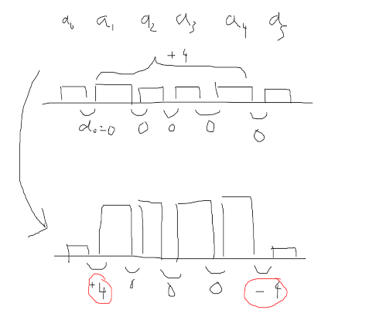

Again, if naïve, $O\left(n\right)$ per update, total time complexity $O\left(nm\right)$.

difference array: $d_{i}=a_{i+1}-a_{i}$

update $\left(l, r, x\right)$: $d_{l-1}+=x d_{r}-=x$

a useful transformation: consider the difference instead of the elements!

two pointers

very general technique, a bit hard to say which situations to use and how to use

Maintain 2 pointers in an array, traverse the array with 2 pointers at the same time

sometime take advantage of a sorted array

Most of the case one of the pointer will be in a for loop

2 types: equal direction, opposite direction

a bit hard to describe so ill just give a bunch of examples

Example 1: find number of subarrays with sum equal to $k$ $\left(n≤{10}^{6}\right)$

(subarray: continuous chunk)

brute force: $O\left(n^{2}\right)$

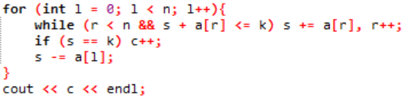Maintain $l$ and $r$, such that $a_{l}+a_{l+1}+…+a_{r}≤k$

$O\left(n\right)$!

Example 2: find if any $a_{i}+a_{j}$ is equal to $k$ $\left(i≠j\right)$ $\left(n≤{10}^{6}\right)$

brute force: $O\left(n^{2}\right)$

Sort the array, initialize $l$ as $0$ and $r$ as $n-1$

if $a_{l}+a_{r}<k$: move $l$ to the right once

if $a_{l}+a_{r}>k$: move $r$ to the left once

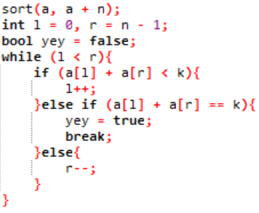

Example 3: find if any $a_{i}+b_{j}$ is equal to $k$ $\left(i≠j\right)$ $\left(n, m≤{10}^{6}\right)$

pretty much same as above, just to show that you can apply 2 pointers in different arrays

actually similar to merging arrays in merge sort

sort both arrays, $l=0$, $r=m-1$

if $a_{l}+b_{r}<k$: move $l$ to the right once

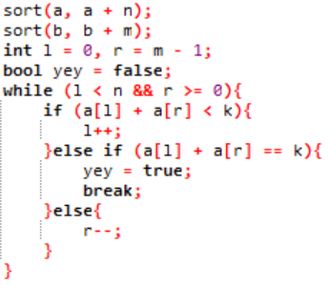if $a_{l}+b_{r}>k$: move $r$ to the left once

Example 4: find if a triplet $\left(a_{x}, a_{y}, a_{z}\right)$ sums to $k$ $\left(n≤{10}^{3}\right)$

3 pointers? nahh

notice $n$ is smaller, can $O\left(n^{2}\right)$

just iterate the $x$, then use 2 pointers like above to find if any $a_{y}+a_{z}=k-a_{x}$!

too lazy to code

Example 5: find if a quadruplet $\left(a_{x}, a_{y}, a_{z}, a_{w}\right)$ sums to $k$ $\left(n≤{10}^{3}\right)$

4 pointers??? no

can be decomposed into 2 pointers + 2 pointers!

First, find the sum of all possible pairs, and store them in an array.

Use example 2 to do 2 pointers on the array with $\frac{n×\left(n-1\right)}{2}$ sums!

Important: need 2 check if the pairs does not have overlapping elements.

time complexity = $O\left(n^{2}\right)+O\left(n^{2}\log{n^{2}}\right)+O(n^{2})$ = $O\left(n^{2}\log{n}\right)$

$\log{n^{2}}=2\log{n}, so O\left(\log{n^{2}}\right)=O\left(\log{n}\right)$

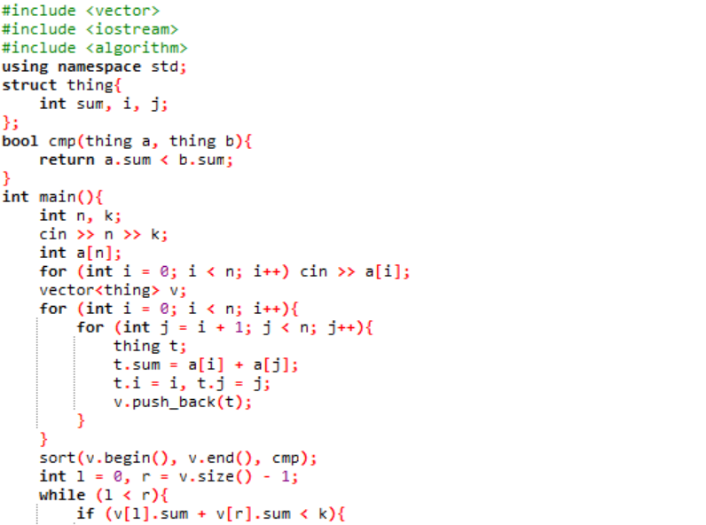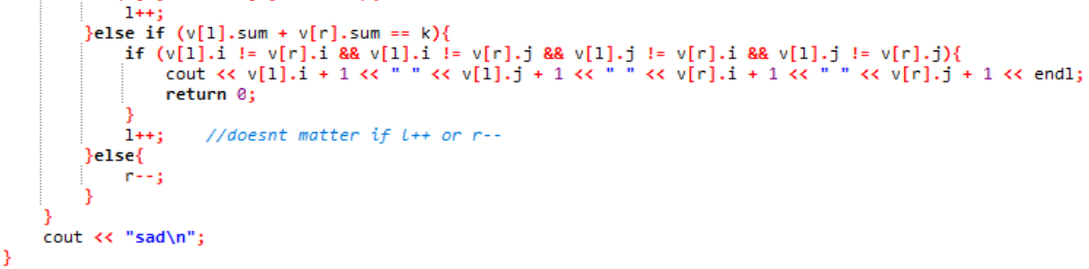

type of 2 pointers: sliding window

maintain $l$ and $r$, and $l$ is in a for loop. There is a property for a subarray, and you need to maintain $r$ such that $l$ to $r$ is the longest subarray that satisfies the property

Like example 1!

Example 6: Find the length of the longest substring without repeating characters $\left(n≤{10}^{6}\right)$

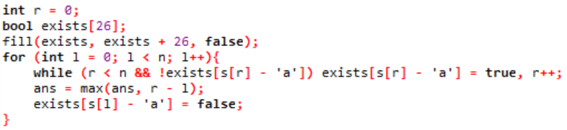maintain $r$ such that $l$ to $r$ is the longest substring without repeating characters

Final notes

prefix array and difference array are useful for thinking about problems from a different perspective, and it is also easy to understand.

2 pointers is a bit hard to get, so just do more 2 pointers problems!

2 pointers problems: S061, M1613, M1812, M1022, M0652, I0611, a lot more

advanced topics: difference array on trees, Floyd’s tortoise and hare